Use Tableau with Apache Kylin
Date: August 2016
Author: Ramón Portolés, Alberto Linkedin

Intro
We can use Quick Start with Sample Cube of Kylin Project to make an example of integration with Tableau Software

Pre-requisites
The First, you need Build Kylin Cube: Quick Start with Sample Cube: With Step 5, you can check the result cube executing:
select part_dt, sum(price) as total_selled, count(distinct seller_id) as sellers from kylin_sales group by part_dt order by part_dt
Query results:
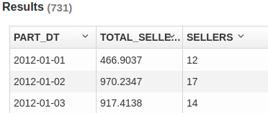
Second, Install Tableau Desktop 9.3.3 On windows

Used Software
- Kylin: 1.5.2
- Kylin ODBC 1.5 (Don’t use v1.3, don’t work)
- Tableau Desktop 9.3.3

Create Connection
- Install Kylin ODBC
- Add DNS System in Windows
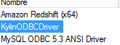
- And configure: User-name /Password: ADMIN / KYLIN
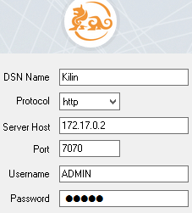
- Click Connect and Choose the project
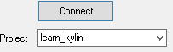
- Click on “Done”
- Download and install Tableu Desktop and launch it
- > >
- >
- Complete details connections (ADMIN /KYLIN), click done, click OK:
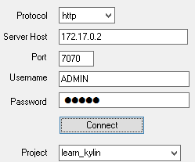
- Click on > > (In magnifying glass)
The result must be, three new tables (on left panel):
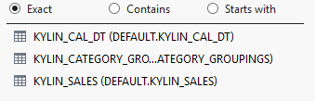
NOTE: Sometimes it doesn’t work fine, Solution: close and open Tableau :)
- Add this tables to Tableau: Drag and Drop to 
- First “Kylin_sales” (Fact Table) and second “Kylin_Cal_DT” (Dimension table)
And Join Relation:
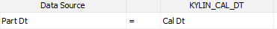
- Now the same with “Kylin_Category_Groupings”
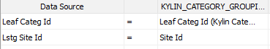
- The result must be:
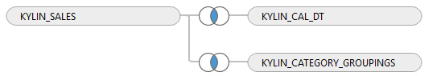
- Now if you click: 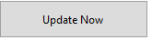, you must see data table:
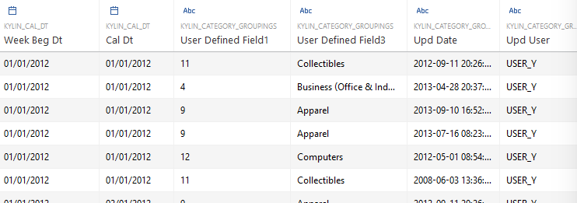

Intro to Sheet Elements
Go to Sheet 1:
You must see the Dimensions in left panel
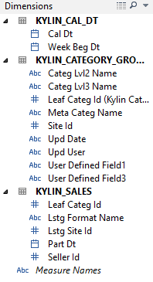

And measures:
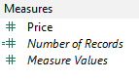

Our First WorkSheet
Drag and Drop “Cal_Dt” and “Price” like in picture:
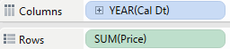

You can expand to Quarter and Months: Click on “Plus” of year:
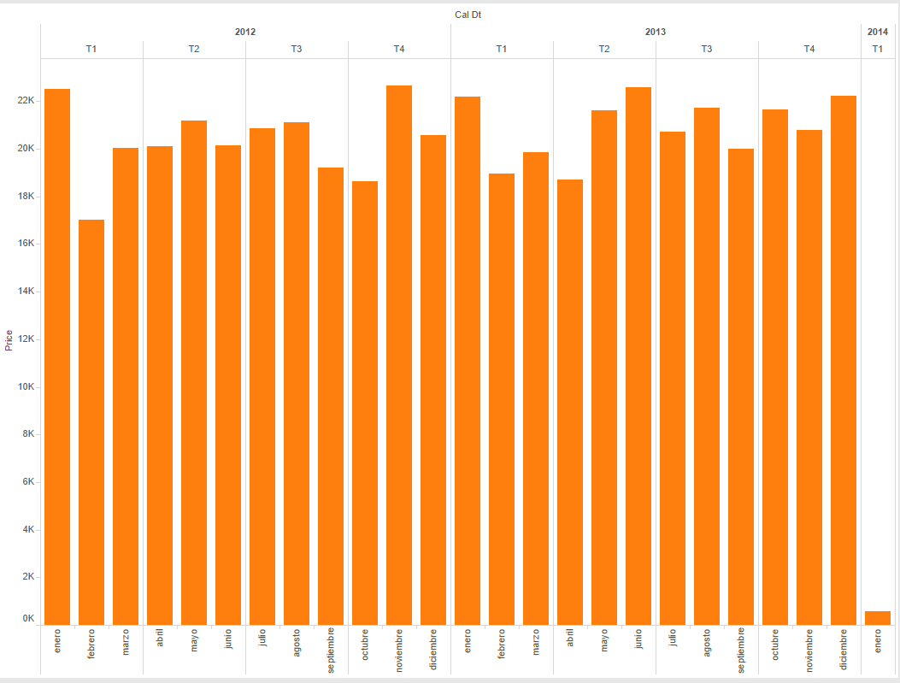

We can add sub-totals by category: Drag and Drop “Meta Categ Name” to “Color”
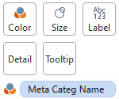
The result must be similar to:
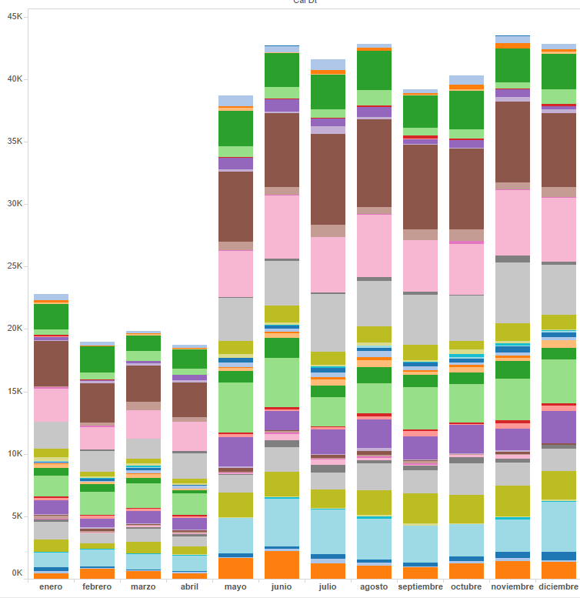

Second Worksheet
Create new Worksheet
Drag and Drop:
After than we can see the relations between “Meta Categ Name”, "L2" and "L3":
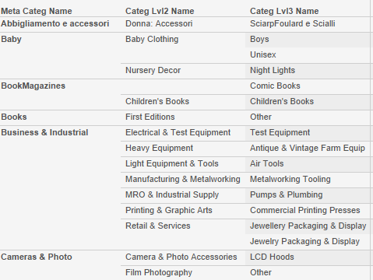
Delete 3 the three fields in “Rows” and generate a hierarchy: using Dimensions Menu (Left side) Drag and Drop “Lvl2” over “Meta Categ Name” and after D & Drop “Lvl3”, the result must be:
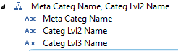
Drag and Drop the New hierarchy on “Rows” and expands
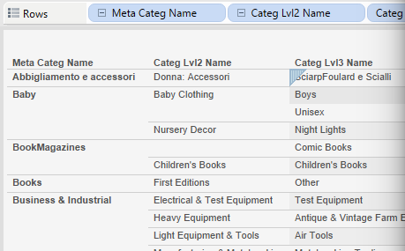
Change the diagram type to table: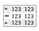

Drag and Drop “Price” to Rows, and see total at right of table:
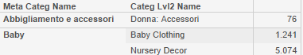
Now you can change the graph type:
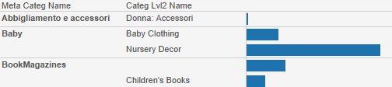

Create Dashboard
Create New Dashboard
Drag and Drop WorkSheet_1 and WorkSheet_2
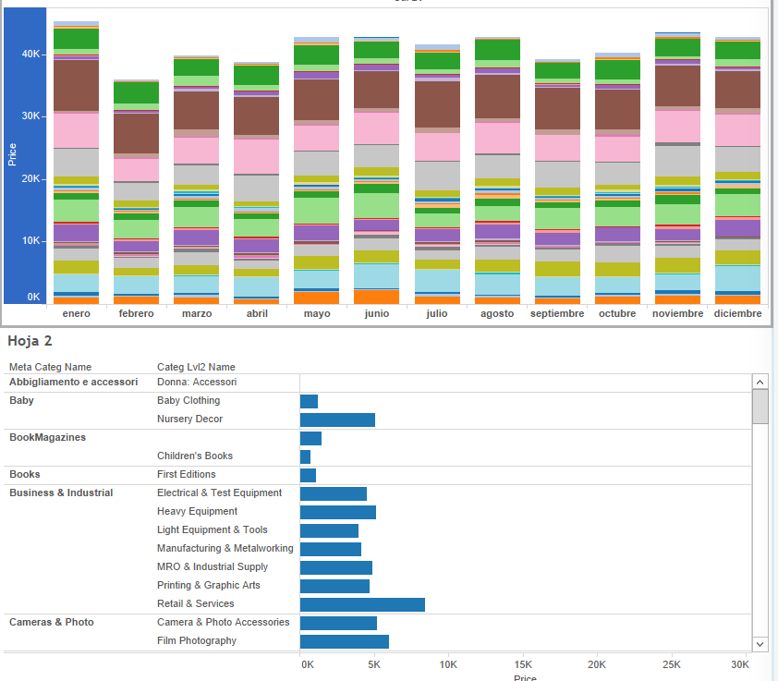

Add filter to dashboard
1º Add Filter to Worksheet_1 : 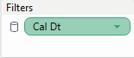
2º Configure the filter like“All Using this Data Source”
3º Then check the Worksheet_2 and we will see a new filter has been apppend: 
4º Add filter to dashboard: Select a Worksheet on Dashboard, and right- click on upper edge
Filter > “Cal Dt”
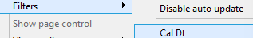

After that a new right panel will appear: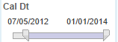, this filter will be affect on all Dashboard’s Worksheet
Furthermore , you can filter by date, clicking in month, on upper worksheet 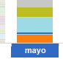
Or, you can filter by category, clicking in category too: 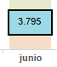

Final Result:
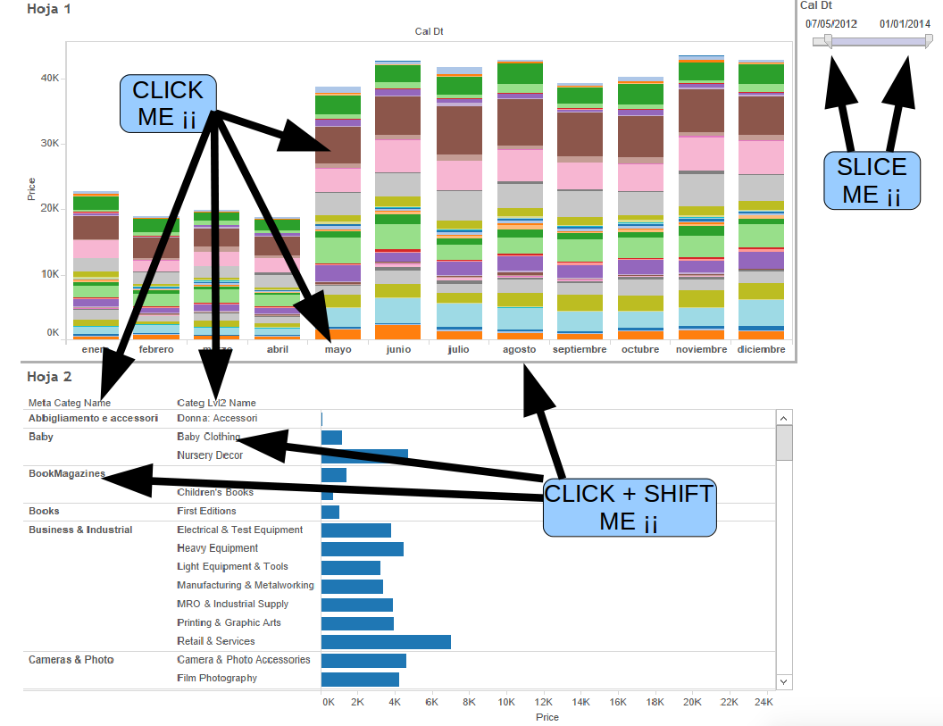
Tableau Files: Full.twb OnlyConnection.twb

For any suggestions, feel free to contact me
Thanks, Alberto

